# “Project Title”

### A Project Submitted to the

### University of Mumbai, Mumbai

### In partial fulfillment of the course work leading to

**Bachelor of Engineering**

**In**

**Electrical Engineering**

### **By**

### **` Mr. Ankit R. Patel**

### **Mr. Sandeep Chaudhari**

## Under the guidance of

Prof. Name of Professor



## Department of Electrical Engineering

**Pillai HOC College of Engineering & Technology,**

**Rasayani - 410207**

**[2017-18]**

**Mahatma Education Society’s**

**Pillai HOC College of Engineering &Technology,**

**Rasayani – 410207**

**2017-2018**



**CERTIFICATE**

This is to certify that the poject titled, **“Project Title”**, duly submitted by the following students-

**Patel Ankit R.,**

**Patel Devang A.**

**Shah Dhruv D.**

has been completed under my supervision in a satisfactory manner in a partial fulfillment of the requirements for the award of Bachleor’s Degree in ***Electronics and Telecommunication Engineering*** to be conferred by the ***University of Mumbai.*** In my opinion, the work embodied in this report is comprehensive and fit for evaluation.

**Project Guide**

**(Prof. -----------)**

**Forwarded for Further Perusal:**

**HoD**

**Prof.Pranita Chavan**

**Principal**

**Dr. Chelpa Lingam**

**Seal of Department**

**PROJECT APPROVAL SHEET**

*The Project Titled “* ***Project Title****” submitted by the students*

***Patel Ankit R.***

***Patel Devang A.***

***Shah Dhruv D.***

*Is examined and approved by the examiners.*

*Sign -------------------------- Sign -----------------------*

*Name ------------------------- Name ---------------------*

*(External Examiner) (Internal Examiner)*

*Date:*

*Place:RASAYANI*

**DECLARATION**

I declare that this written submission represents my ideas in my own words and where others' ideas or words have been included, I have adequately cited and referenced the original sources. I also declare that I have adhered to all principles of academic honesty and integrity and have not misrepresented or fabricated or falsified any idea/data/fact/source in my submission. I understand that any violation of the above will be cause for disciplinary action by the Institute and can also evoke penal action from the sources which have thus not been properly cited or from whom proper permission has not been taken when needed.

----------------------------------

**(Signature)**

**(Student Name.)**

**ACKNOWLEDGEMENT**

I would like to express my sincere gratitude towards my guide**, -------,** for the help, guidance and encouragement, she provided during the special topic seminar. This work would have not been possible without her valuable time, patience and motivation. It was great learning and an honor being her student.

I am indebted to the entire team in the Department of Electrical Engineering. They supported me with scientific guidance, advice and encouragement, they were always helpful and enthusiastic and this inspired me in my work.

I take the privilege to express my sincere thanks to **------------,** our principal for providing the encouragement and much support throughout my work.

Last but not least, I would like to thank my family for always encouraging me and supporting me throughout life.

**Contents**

|  |  |  |  |
| --- | --- | --- | --- |
| **Sr. No.** | | **Contents** | Page No. |
|  |  | **Certificate** | **(i)** |
|  |  | **Project Approval sheet** | **(ii)** |
|  |  | **Declaration** | **(iii)** |
|  |  | **Acknowledgement** | **(iv)** |
|  |  | **Contents** | **(v)** |
|  |  | **List of Figures** | **(vi)** |
|  |  | **List of Tables** | **(vii)** |
|  |  | **Abstract** | **(viii)** |
| **1** |  | **Introduction** | **1** |
| **2** |  | **Basic Concepts & Literature Survey** | **2** |
|  | 2.1 | Literature survey |  |
|  | 2.2 | Need and Scope of Project |  |
| **3** |  | **Design Methodology** | **3** |
| Chapter Heading, 12 Times New Roman, Bold, Sub heading 11 Times New Roman, Page Nos. Right align, Do not give page no or Chapter no to **Appendix** Chapter (Last Chapter), Also start your Content form **Introduction** as First Chapter, After that Second Chapter must be **Basic Concept and Literature Survey,** after second chapter for arrangement of remaining chapter see instructions, Try to arrange report within 6-7 chapters | 3.1 | Block Diagram *(Add Explaination)* | **4** |
|  | 3.2 | Description of System | **5** |
|  | 3.3 | Circuit Diagram *(Add Explaination)* | **6** |
|  | 3.4 | Flow Chart | **7** |
| **4** |  | **Component List** *(Add component Costings)* | **8** |
| **5** |  | **Hardware Details** | **10** |
| **5** |  | **Software Details** | **12** |
|  | 5.1 | *(Add Software details you are using)* | **14** |
| **6.** |  | **Implementation of System** | **15** |
|  | 6.1 | Hardware Implementation | **16** |
|  | 6.2 | Software Implementation | **17** |
| **7** |  | **Results** | **60** |
| **8** |  | **Application & Future Scope** | **61** |
| 9 |  | **Conclusion** | **62** |
| **10** |  | **References** | **64** |
| **11** |  | **Appendix (If required)** | **65** |

**Abstract**

In smart-grid area, the devices for end-consumers are one of the most important items. This paper presents a device developed to be installed in conventional refrigerators and freezers (white-line apparatus). Its main idea is change the daily load profile, moving the load from the peak-load period to a period before the peak-load. The proposed device inputs collect automatically consumer habits and apparatus features, such as: frequency and time of door opening of white-line apparatus during the peak-load period, the internal temperature, the equipment thermo-dynamic features, among others. And then, after an information computational process, the device provide the command on/off for the white-line apparatus compressor. Finally, this paper presents some practical results in real-life apparatus.

**Introduction**

End-consumer devices and strategies are included in one of the fundamental areas in smart-grid technologies, named load management. The importance of this area is to help generation, transmission, and distribution system in load supply [1]. Currently, some white-line apparatus such as refrigerators and freezers have a continuous operation of their motors throughout the day. The operation of the engine is related with the variation of internal and external temperature conditions in these apparatus. Before the smart-grid ideas, these apparatus had their operation related to their typical self-characteristics. Currently, these apparatus are starting to be prepared to a new phase, where load management concepts are incorporated to improve not only their productivity but the global system efficiency. Many strategies can be implemented to accomplish that. The improvement provided by the proposed device has been obtained only by increasing the degree of control, both on the part of the electric drive of compressors engines as in the form of acting in these engines in terms of various quirks and a control algorithm with some degree of intelligence. The main purpose of the proposed device was developed to reduce the peak-load demand of the power distribution companies [2]. This reduction allows the improvement of consumer load profile, without concern for your total consumption because it remains the same, that is, the load is simply shifted from the period. The control strategy of the proposed device is based on thermal dynamic estimation related to existent products inside the apparatus, and with consumer consumption habits. The strategy produces a compressor operation appropriate to the needs of both the power company and the user.

**Basic Concepts & Literature Survey**

**Literature Survey**

Currently, some white-line apparatus such as refrigerators and freezers have a continuous operation of their motors throughout the day. The operation of the engine is related with the variation of internal and external temperature conditions in these apparatus. Before the smart-grid ideas, these apparatus had their operation related to their typical self-characteristics

High peak demand is often a challenge to the grid and could result into measures such as procurement of additional plants to meet the peak demand, higher tariffs for consumers, undesirable load shedding or even black-outs

Dynamic pricing of electricity Although academicians and researchers see the study of dynamic pricing of electricity as useful and interesting, regulators, suppliers and customers have stayed away from large scale deployment of this concept. There are doubts regarding the potential benefit over the cost implementation and possible excessive high bill value to customer.

from

large-scale deployment of this concept

from

large-scale deployment of this concept

**Need and Scope of Project**

The operation of the engine is related with the variation of internal and external temperature conditions in these apparatus. Before the smart-grid ideas, these apparatus had their operation related to their typical self-characteristics. Currently, these apparatus are starting to be prepared to a new phase, where load management concepts are incorporated to improve not only their productivity but the global system efficiency. Many strategies can be implemented to accomplish that.

This paper report presents a device for refrigerators and freezers. The improvement provided by the proposed device has been obtained only by increasing the degree of control, both on the part of the electric drive of compressors engines as in the form of acting in these engines in terms of various quirks and a control algorithm with some degree of intelligence. The main purpose of the proposed device was developed to reduce the peak-load demand of the power distribution companies. This reduction allows the improvement of consumer load profile, without concern for your total consumption because it remains the same, that is, the load is simply shifted from the period. The control strategy of the proposed device is based on thermal dynamic estimation related to existent products inside the apparatus, and with consumer consumption habits. The strategy produces a compressor operation appropriate to the needs of both the power company and the user

Current coolers store the foods at a temperature ranging from 3°C to 5°C. At these temperatures, the activity of the microorganisms responsible for the deterioration of food becomes slower, however does not diminish. The freezer maintains a temperature around -18°C. Under these conditions, the microorganisms do not reproduce and effectively decreasing the deterioration of food. The thermistor is responsible for transmitting the inner temperature variation from the fridge to the control that activates the compressor. The speed of response of a typical thermistor in standard refrigerators indicates that it is able to be used for lifting of variations in temperature when the door is opened or when you enter a thermal load. This responsiveness is essential for the refrigerator temperature control and for this project

**Block Diagram**

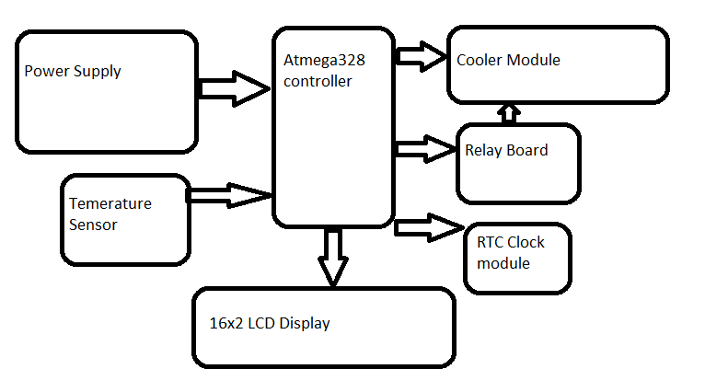

**Description**

In this project we use atmega328 controller for controlling device & monitoring .controller interface with various device like temperature sensor, relay board, LCD Display & RTC clock module. Temperature sensor measure temperature .controller monitor temperature reading .cooler fan will on or off depending upon threshold value set in controller board. Also display the temperature value on LCD display. Relay board connect between controller & cooler fan. Controller send signal to relay on or off. Depending upon relay on or off cooler fan will on or off. Cooler fan connected to relay board. We use LM35 temperature sensor for measuring temperature. We use 16x2 LCD display for display value .RTC clock is handy module keeps accurate time for years using a tiny coin-cell. Perfect for clock projects, data loggers or anything that needs to know the date and time. Using RTC Clock module we set the peak hour so we adjust the on or off time. Depending upon programming when set time match with rtc clock module then Cooler structure on & off .so using RTC clock we set Peak hour.so we can consume energy. We use thermocouple module cooling the internal structure inside refrigerator. Current sensor measure the current through cooling structure .So using this method we can consume lot off consume energy.

**Flowchart**

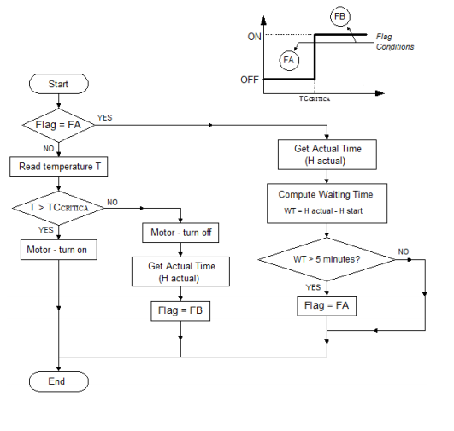

**Hardware Specifications:**

* Relay
* Atmega328 (Arduino nano board)
* Current Sensor Module
* IR sensor Module
* Transformer
* Capacitors
* Diodes
* Lcd display
* TEC1-12712 thermoelectric cooler module
* RTC Clock

**Software Specifications:**

* MC Programming Language: C
* Diptrace

**HARDWARE**

1. **POWER SUPPLY :**

The essential components of power supply are Transformer, four diodes which forms bridge rectifier, capacitor works as filter and positive voltage regulator IC LM7805. IC LM7805 has an internal thermal overload protection and the internal short circuit current limiting device.

IC LM7805 is a 5V Voltage Regulator that restricts the voltage output to +5V and draws 5V regulated power supply. It comes with provision to add heat sink. The maximum value for input to the voltage regulator is 35V. It can provide a constant steady voltage flow of 5V for higher voltage input till the threshold limit of 35V. If the voltage is near to 7.5V then it does not produce any heat and hence no need for heat sink. If the voltage input is more, then excess electricity is liberated as heat from 7805. Voltage regulator IC maintains the output voltage at a constant value. 7805 & 7812 , a voltage regulator integrated circuit (IC) is a member of 78xx series of fixed linear voltage regulator ICs used to maintain such fluctuations.[9]

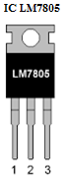

Voltage regulator IC 7805

The three terminals are:

1. Unregulated voltage Input

2. Ground

3. Regulated voltage output

**TRANSFORMER :**

Transformer used is the step down transformer to reduce 230 volt to +12 volt. It provides isolation from the mains. Step down transformers are mainly designed to reduce electrical voltage.

**RECTIFIER :**

The rectifier is used to convert A.C to D.C voltage. The designed that we have carried out is of the full wave bridge rectifier circuit diode 4007 are use. The full wave bridge rectifier has advantage over the full wave rectifier like the need of center-tapped transformer is eliminated.

1. **LCD DISPLAY :**

LCD (Liquid Crystal Display) screen is an electronic display module and find a wide range of applications. A 16x2 LCD display is very basic module and is very commonly used in various devices and circuits. LCD creates images on a flat surface by shining light through a combination of Liquid crystals and polarized glass. LCDs are economical; easily programmable; have no limitation of displaying special & even custom characters (unlike in seven segments), [animations](http://www.engineersgarage.com/microcontroller/8051projects/display-custom-animations-LCD-AT89C51) and so on.

A 16x2 LCD means it can display 16 characters per line and there are 2 such lines. In this LCD each character is displayed in 5x7 pixel matrix. This LCD has two registers, namely, command and data.[11]

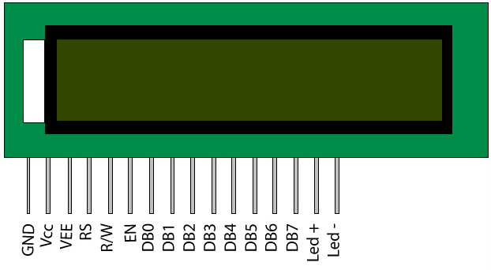

Fig 5.6 LCD display

**Pin Description :-**

|  |  |  |
| --- | --- | --- |
| **Pin no.** | **Functions** | **Name** |
| 1. | Ground | Ground |
| 2. | Supply voltage 5V(4.7V-5.3V) | Vcc |
| 3. | Contrast adjustment; through a variable resistor | VEE |
| 4. | Selects command resistor when low; and data data resistor when high | Register  Select |
| 5. | Low to write to the register; High to read from the register | Read/  Write |
| 6. | Sends data to data pins when high to low pulse given | Enable |
| 7-14 | 8-bit data pins | DB0-DB7 |
| 15. | Backlight Vcc (5V) | LED+ |
| 16. | Backlight Ground (0V) | LED - |

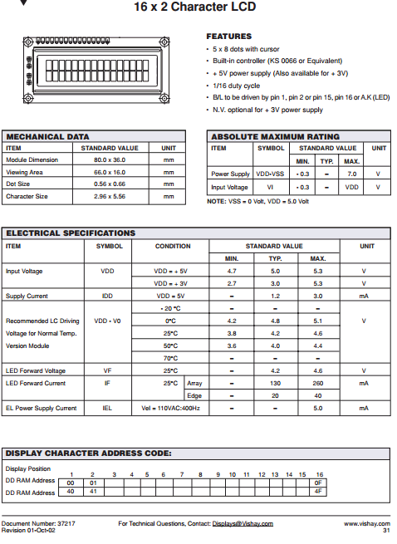

1. **RELAY**

An electrically operated devices that open and closes the auxillary circuits under predetermined conditions in the mains circuits is called relay. It consist of mechanism to make or break connections in the electrical or electronic circuit. Relay is an electromagnetic device which is used to isolate two circuits electrically and connect them magnetically. They are very useful devices and allow one circuit to switch another one while they are completely separate. They are often used to interface an electronic circuit (working at a low voltage) to an electrical circuit which works at very high voltage. The loads of electric appliances are directly connected to relays.[10]

A relay switch can be divided into two parts: input and output. The input section has a coil which generates magnetic field when a small voltage from an electronic circuit is applied to it. This voltage is called the operating voltage. Commonly used relays are available in different configuration of operating voltages like 5V- 24V etc. The output section consists of contactors which connect or disconnect mechanically. In a basic relay there are three contactors: normally open (NO), normally closed (NC) and common (COM). At no input state, the COM is connected to NC. When the operating voltage is applied the relay coil gets energized and the COM changes contact to NO. Different relay configurations are available like SPST, SPDT, DPDT etc, which have different number of changeover contacts. By using proper combination of contactors, the electrical circuit can be switched on and off. Get inner details about structure of a relay switch.

contacts close, we have a working relay.

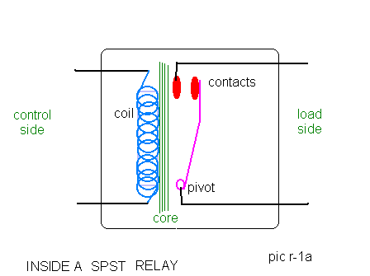

The simplest relay is the Single Pole, Single Throw (spst) relay. It is nothing more than an electrically controlled on-off switch. Its biggest property is the ability to use a very small current, to control a much larger current

1. **ACS712 CURRENT SENSOR MODULE**

Sensing and controlling current flow is a fundamental requirement in a wide variety of applications including, over-current protection circuits, battery chargers, switching mode power supplies, digital watt meters, programmable current sources, etc. This ACS721 current module is based on ACS712 sensor, which can accurately detect AC or DC current. The maximum AC or DC that can be detected can reach 5A, and the present current signal can be read via analog I / O port of Arduino.

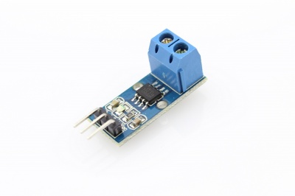

**Features:**

* Supply Voltage: 4.5V~5.5V DC
* Measure Current Range: -1A~ 5A
* Sensitivity: 180mV/A ~190mV/A, Typical: 185mV/A

1. **Atmega328 Controller(Arduino nano)**

* **Arduino Nano** is a [microcontroller](https://www.theengineeringprojects.com/2018/03/introduction-to-microcontrollers.html) board, developed by Arduino.cc and based on ATmega 328p/Atmega 168.
* It comes with an operating voltage of 5V, however, the input voltage can vary from 7 to 12V.
* There are 14 digital pins which can be configured as input or output and 8 analog pins incorporated on the board. More or less all these analog pins can be used and configured exactly the same way as digital pins.
* Digital pins are used as input pins when they are interfaced with sensors while driving of load is carried out when digitals are used as output.
* Functions like pinMode() and digitalWrite()  are used to control the operations of digital pins while analogRead() is used to control analog pins.
* The analog pins come with a total resolution of 10bits which measure the value from zero to 5V
* Arduino Nano comes with a crystal oscillator of frequency 16 MHz. It is used to produce a clock of precise frequency using constant voltage.
* There is one limitation using Arduino Nano i.e. it doesn’t come with DC power jack, means you can not supply external power source through a battery.
* This board doesn’t use standard USB for connection with a computer, instead, it comes with Mini USB support.
* Tiny size and breadboard friendly nature make this device an ideal choice for most of the applications where a size of the electronic components are of great concern.
* Flash memory is 16KB or 32KB that all depends on the Atmega board i.e Atmega168 comes with 16KB of flash memory while Atmega328 comes with a flash memory of 32KB. Flash memory is used for storing code. The 2KB of memory out of total flash memory is used for a bootloader.

[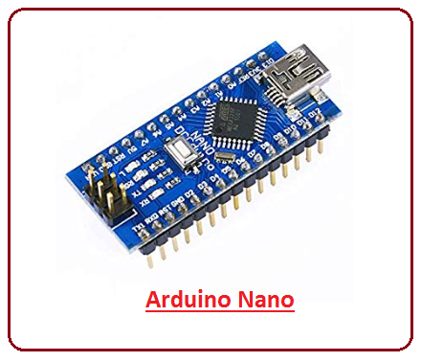](https://www.theengineeringprojects.com/wp-content/uploads/2018/06/introduction-to-arduino-nano-5.png)

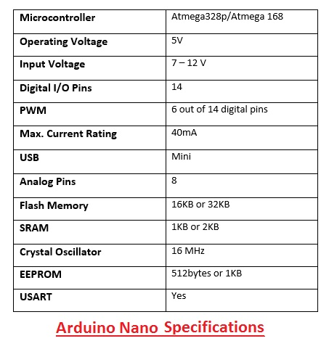

# **Thermoelectric Peltier Cooler or Cooling module**

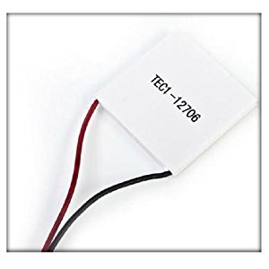

### Tec 12706 Peltier Unit

A Peltier unit is an electric device that,

1. Convert temperature difference into voltage.

2. Convert voltage into temperature difference.

Working

Thermoelectric cooling uses the Peltier effect to create a heat flux between the junctions of two different types of materials. A Peltier cooler, heater, or thermoelectric heat pump is a solid-state active heat pump which transfers heat from one side of the device to the other, with consumption of electrical energy, depending on the direction of the current. Such an instrument is also called a Peltier device, Peltier heat pump, solid state refrigerator, or thermoelectric cooler (TEC). It can be used either for heating or for cooling, although in practice the main application is cooling. It can also be used as a temperature controller that either heats or cools.

# **Cooling Fan**

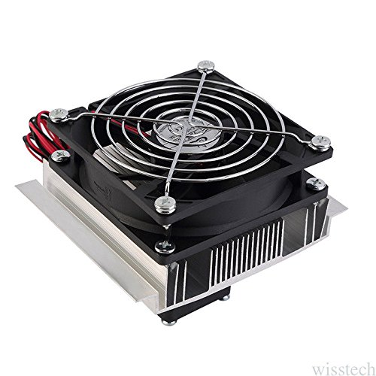

thermoelectric peltier refrigeration cooling cooler fan system heatsink Convenient to use it is very helpful and useful lightweight and small size durable and practical semiconductor coolers are a form of solid state cooling that incorporates both semiconductor technologies and electronic assembly techniques. Must fittng radiator heatsink when power on.Many older refrigerators and most small refrigerators (like small bar and dorm refrigerators) do not have fans, but most modern **frost-free** refrigerators have two. One is under the refrigerator to cool the compressor and force air through the exterior coils. The second is inside and moves air around the coils inside the refrigerator. This second fan helps provide more even cooling, and also aids in the defrost proces

1. **Temperature Sensor**

**LM35** is a precision IC [**temperature sensor**](http://www.engineersgarage.com/articles/temperature-sensors) with its output proportional to the temperature (in **o**C). The sensor circuitry is sealed and therefore it is not subjected to oxidation and other processes. With **LM35**, temperature can be measured more accurately than with a thermistor. It also possess low self heating and does not cause more than 0.1**o**C temperature rise in still air.

 The operating temperature range is from -55°C to 150°C. The output voltage varies by 10mV in response to every **o**C rise/fall in ambient temperature, *i.e.,*its scale factor is 0.01V/**o**C.

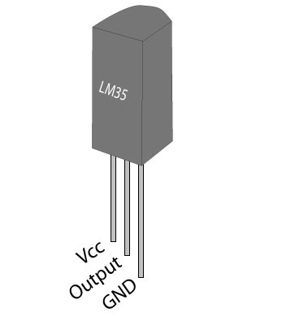

### Pin Description:

|  |  |  |
| --- | --- | --- |
| **Pin No** | **Function** | **Name** |
| 1 | Supply voltage; 5V (+35V to -2V) | Vcc |
| 2 | Output voltage (+6V to -1V) | Output |
| 3 | Ground (0V) | Ground |

**SOFTWARE**

1. **DIPTRACE SOFTWARE :**

**Dip Trace** is EDA software for creating [schematic](http://en.wikipedia.org/wiki/Schematic) diagrams and [printed circuit boards](http://en.wikipedia.org/wiki/Printed_circuit_board). Layout design using Dip trace software Schematic Capture is advanced circuit design tool with support of multi-sheet and multi-level hierarchical schematics. This module of Dip Trace delivers number of features for visual and logical pin connections. Cross-modules management ensures that principal circuits can be easily converted to PCB, back annotated or imported/exported from/to other EDA, CAD and net-list formats. Verification and Spice export for simulation allow for full project analysis.

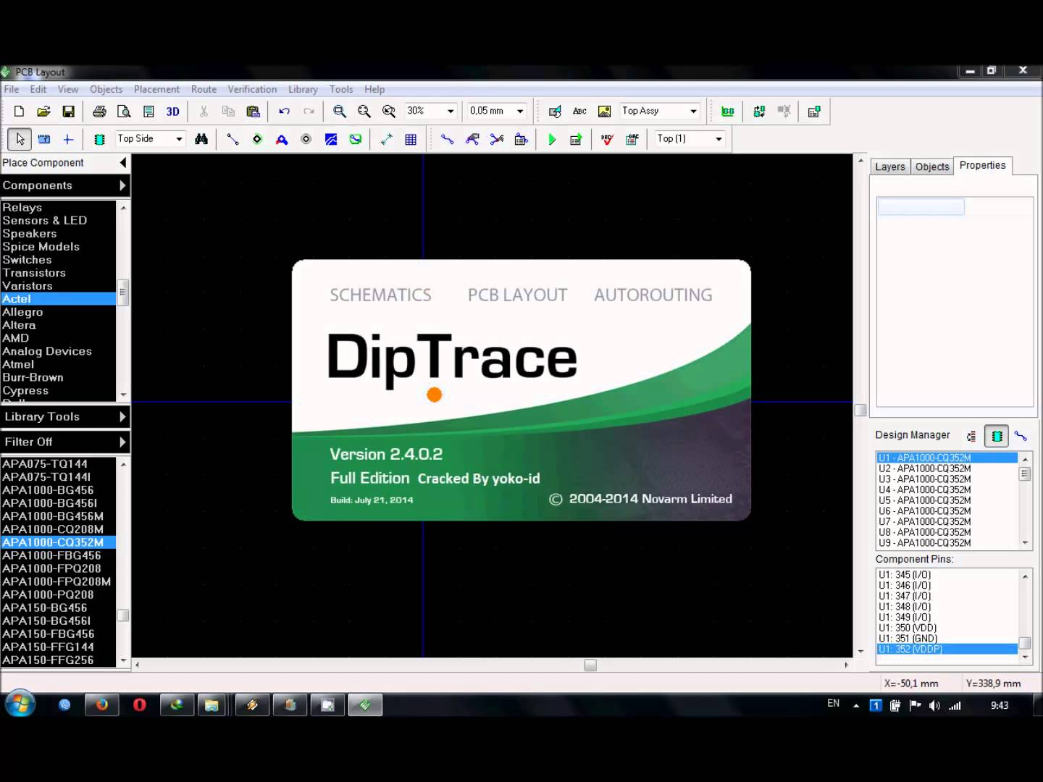

1. **ARDUINO SOFTWARE:**

The open-source Arduino Software (IDE) makes it easy to write code and upload it to the board. It runs on Windows, Mac OS X, and Linux. The environment is written in Java and based on Processing and other open-source software.

The Arduino [integrated development environment](https://en.wikipedia.org/wiki/Integrated_development_environment) (IDE) is a [cross-platform](https://en.wikipedia.org/wiki/Cross-platform) application written in [Java](https://en.wikipedia.org/wiki/Java_%28programming_language%29), and derives from the IDE for the [Processing programming language](https://en.wikipedia.org/wiki/Processing_%28programming_language%29) and the [Wiring](https://en.wikipedia.org/wiki/Wiring_%28development_platform%29) projects. It is designed to introduce programming to artists and other newcomers unfamiliar with software development. It includes a code editor with features such as [syntax highlighting](https://en.wikipedia.org/wiki/Syntax_highlighting), [brace matching](https://en.wikipedia.org/wiki/Brace_matching), and automatic indentation, and is also capable of compiling and uploading programs to the board with a single click. A program or code written for Arduino is called a "sketch".

Arduino programs are written in [C](https://en.wikipedia.org/wiki/C_%28programming_language%29) or [C++](https://en.wikipedia.org/wiki/C%2B%2B). The Arduino IDE comes with a [software library](https://en.wikipedia.org/wiki/Software_library) called "[Wiring](https://en.wikipedia.org/wiki/Wiring_%28development_platform%29)" from the original Wiring project, which makes many common input/output operations much easier. The users need only to define two functions to make an executable [cyclic executive](https://en.wikipedia.org/wiki/Cyclic_executive) program:

Setup (): a function that runs once at the start of a program and that can initialize settings.Loop : a function called repeatedly until the board powers off.

A typical first program for a microcontroller simply blinks an [LED](https://en.wikipedia.org/wiki/Light-emitting_diode) on and off. In the Arduino environment, the user might write a program like this:

Power LED (Red) and Integrated LED on Line 13 (Green) on Arduino Compatible Board.

Most Arduino boards contain an LED and a load resistor connected between the pin 13 and ground, which is a convenient feature for many simple tests. The previous code would not be seen by a standard C++ compiler as a valid program, so when the user clicks the "Upload to I/O board" button in the IDE, a copy of the code is written to a temporary file with an extra include header at the top and a very simple [main function](https://en.wikipedia.org/wiki/Main_function) at the bottom, to make it a valid C++ program.

**DEVELOPMET STAGES & PROCESS:**

The complete development of this system can be divided into the following stages:

* Problem definition stage;
* Designing block diagram;
* Implementing circuits and components;
* Developing algorithm for software;
* Writing actual code for Microcontroller;
* Compiling the code;
* Burning the hex file into controller with programmer;
* Testing and Running.
* **Problem definition stage**

This is the very first stage to develop any project. It actually defines the aim and the concept of the project.

* **Designing block diagram**

At this stage we have categorized the whole system into different individual modules. These modules (block diagrams) will be helpful in understanding the concept and working of the integrated system. It also simplifies the entire debugging and testing process.

* **Implementing circuits and components**

This is the actual implementation of circuit of each block. At this stage we have actually designed each block separately and finally integrated them into the complete working system.

* **Developing algorithm for software**

To get the logical flow of the software, the development of algorithm is having a prominent role. So that we have analyzed the complete system and organized the algorithm in such a manner that one can understand the complete working of the software.

* **writing actual code for Microcontroller**

After the development of the algorithm and flowchart we have actually translated them in C language for Atmega328 Microcontroller so that it can understand the instructions and run as per our requirement.

* **Compiling the code**

The code is implemented on the computer for which we have used Arduino IDE pre-installed on PC. Proteus software used for simulate working of Microcontroller in real time without burning the software into actual IC. We simulated and compiled our program for error checking. After removing of several compiling errors the program was converted into machine language.

* **Burning the hex file into microcontroller with Programmer**

In this stage the compiled hex format file was downloaded or burned into controller. This was done with the help of Arduino IDE or PROGISP Programmer

* **Testing and Running**

This time we tested our project for actual working, after loading the software into the microcontroller. Any errors found were removed successfully. This is the last and final stage of development of our project.

**PROCEDURE OF** MAKE **A PCB**

## Step 1: Design your schematics and print them

Download any design or make your own.  
Print the design On glossy photo paper Or magazine paper using laser printer Only.  
If you don't have a laser printer then you can draw the design with permanent marker on the copper clad board.

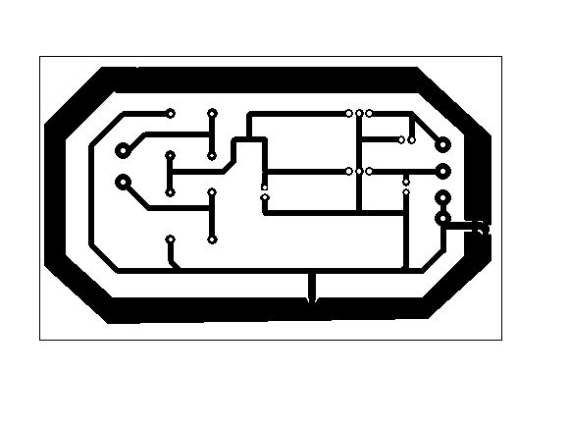

## Step 2: Prepare your copper clad board

1. Apply liquid soap or dishwasher liquid on the copper clad board  
2. Rubs wool on it till it gets shiny  
3. Rub it with scotch-brite  
4. Soak it with water  
5. Finally, clean it with a cloth

**Step 3: Toner transfer (transfer of toner onto the board)**

1. Heat the iron to its maximum setting.  
2. Cut the design and place it upside-down on the board and make sure that it is completely on the board.

3. Slowly move and press the iron on the board with pressure for 20-25 minutes.

**Step 4: Washing the board and completely removing the paper**

After Heating, Wash The Board With Water Till the Paper Completely Gets Removed, Now Only Black lines are left on the board **DO NOT REMOVE THOSE LINES**. after that iF There Are an**y** non transferred lines then grab a permanent marker and draw the Lines.

## Step 5: The Etching Method

**1.** Boil approx. 500 ml Of Water 15-20 minutes. The Hotter the Water is, the Less time the etching method will take.  
**2.** Pour ferric chloride in the small container.

**3.**Keep checking that the copper is removed or not.  
Hold the board with tweezers (not with hands like i am doing, as it is a chemical).  
**4.**If the copper is completely removed (Like This) then, the etching is done.

## Step 6: Washing It

Now Hold The Board With Spoon Or Tweezers And Wash It With Water And Make Sure That The Chemical Is Completely Removed

## Step 7: Remove the toner, and made A PCB

Remove the toner with a steel wool like it’s shown in the picture, And you made a PCB.

## Step 8: Drill

Drill the PCB with A 1mm Drill Bit.

## Step 9: Solder the components and its ready

**Results**

We analysing the data related to the load offset during the peak-load periods in various types of refrigerators, it can be concluded that the system was able to achieve its aim by promoting throughout the period the period of energy saving tip of the system, with an average of 51%.

**Application & Future Scope**

**Application**

* Use in home automation
* Industrial automation
* Air-condition

**Furure Scope**

* IoT technology coupled with smart meters and smart devices can help in the upbringing the cities into smarter and developed cities.
* Many home appliance can control using Rtc clock module.
* Using gsm module we will monitor temperature reading & control device.

**CONCLUSIONS**

This Report presents a device for load management. This device produces a load offset during the peak load period for white-line apparatus. This device based on a strategy related to the consumer habits and refrigerator (or freezer) features allows a control of the apparatus in different types of situations. Analysing the data related to the load offset during the peak-load periods in various types of refrigerators, and for various types of habits, it can be concluded that the system was able to achieve its aim by promoting throughout the period the period of energy saving tip of the system, with an average of 51%.

**REFERENCES**

[1] G. Lambert-Torres – “Notes in Short-Course - Introduction of SmartGrids”, In: 1st Summer School “Trustworthy and Energy-Efficient Smart Grids, Itajuba, Brazil, March 21, 2012.

[2] H.G. Arango, A.C.Z. de Souza, G. Lambert-Torres and A.P. Alves da Silva - “Difference Between Regular and Deterministic Chaos Processes Based on Time Analysis of Load: An Example using CEMIG Data”, Electric Power Systems Research, Vol. 56, pp.35-41, Elvesier Science, 2000.

[3] G. Lambert-Torres, L.E. Borges da Silva, L. Zamboni, C.H.V. de Moraes, P.H.R.P. Gama, A.R. Aoki, and R.J. Riella – “Extracting Procedures and Knowledge from Residential Device Database”, IEEE PES 2011 General Meeting, 2011 IEEE PES GM, Paper 1344, ISBN 978-1-4577-1002-5, Detroit, USA, DOI 10.1109/PES.2011.6039756, Jul. 26-29, 2011

[4] O.M. Longe, K. Ouahada, H.C. Ferreira and S. Rimer-“ CONSUMER PREFERENCE ELECTRICITY USAGE PLAN FORDEMAND SIDE MANAGEMENT IN THE SMART GRID” Electrical & Electronics Engineering Science,University of Johannesburg, P O Box 542, Auckland Park Kingsway, 2006, Johannesburg,South Africa. wunmigrace@yahoo.com, kouahada@uj.ac.za, hcferreira@uj.ac.za, suvendic@uj.ac.za